data tables on Accounting – UI & UX case study

Data is useless without the ability to visualize and act on it. The success of future industries will couple advanced data collection with a better user experience, and the data table comprises much of this user experience.

Good data tables allow users to scan, analyze, compare, filter, sort, and manipulate information to derive insights and commit actions. This article presents a list of design structures, interaction patterns, and techniques to help you design better data tables.

### Fixed Header



Fixing the row header as a user scrolls provides context on what column the user is on.

### Horizontal Scroll

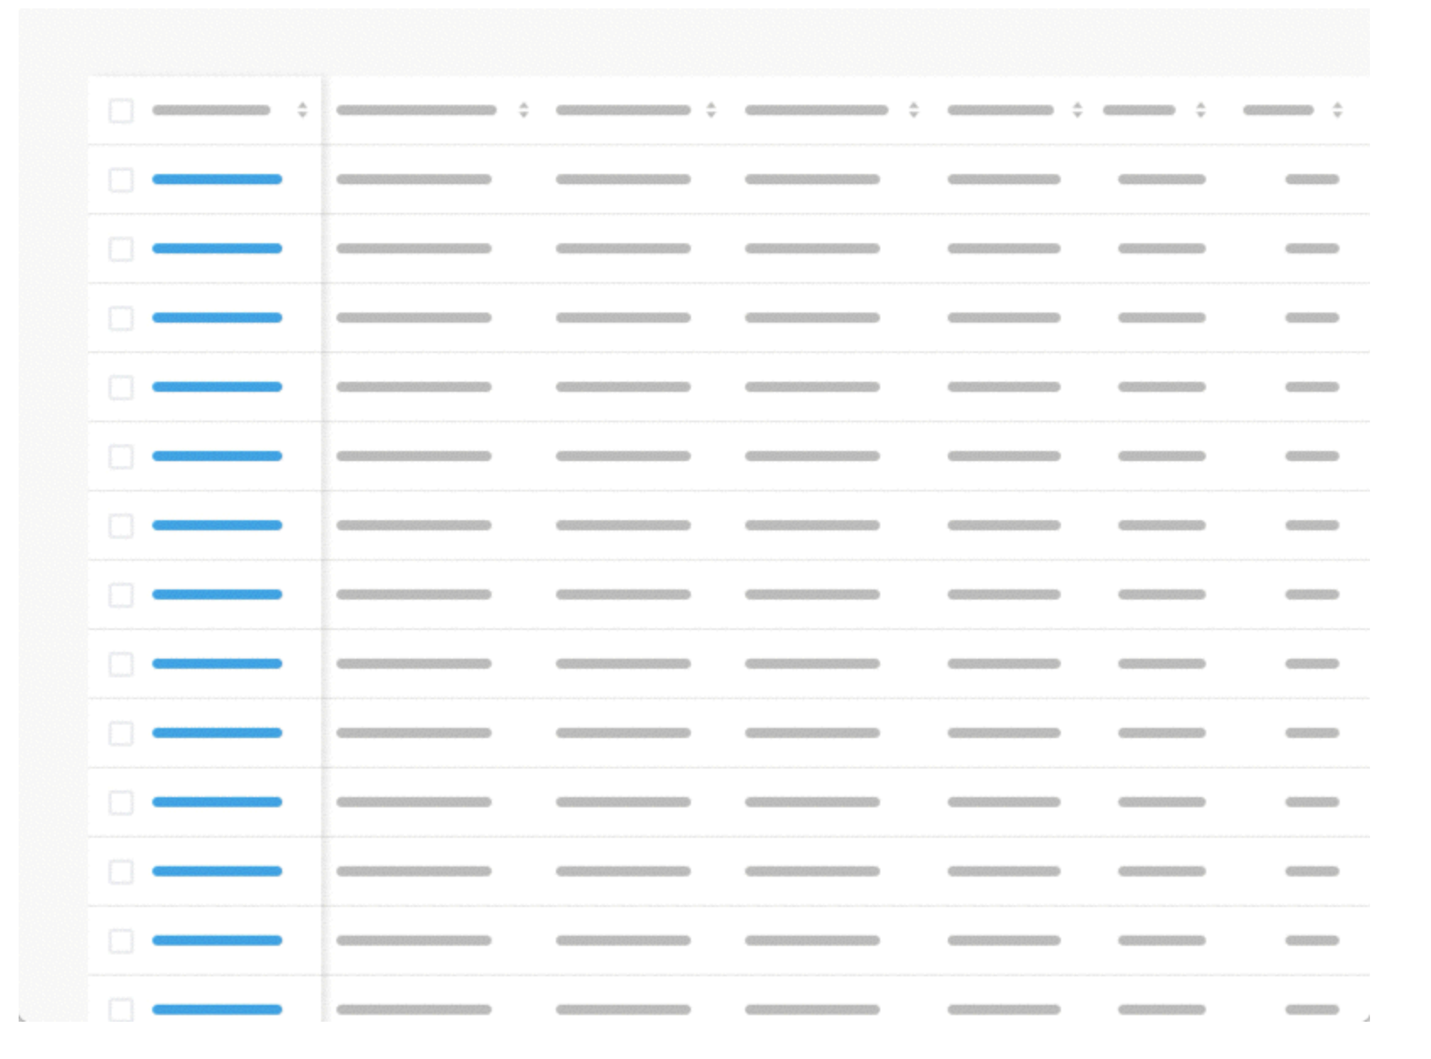

Horizontal scrolling is inevitable when presenting large datasets. It is good practice to place identifier data in the first column. As an advanced feature, enable individual locking of columns so users can compare data with multiple anchoring identifiers.

### Resizable columns

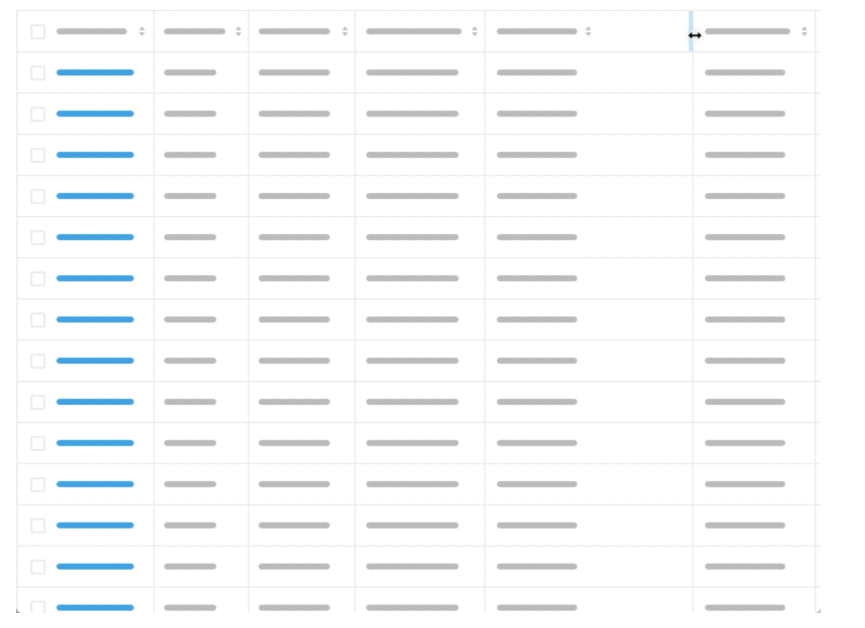

Resizing columns allows users to see abbreviated data in full.

### Row Style

**Zebra Stripes, Line Divisions, Free Form.**

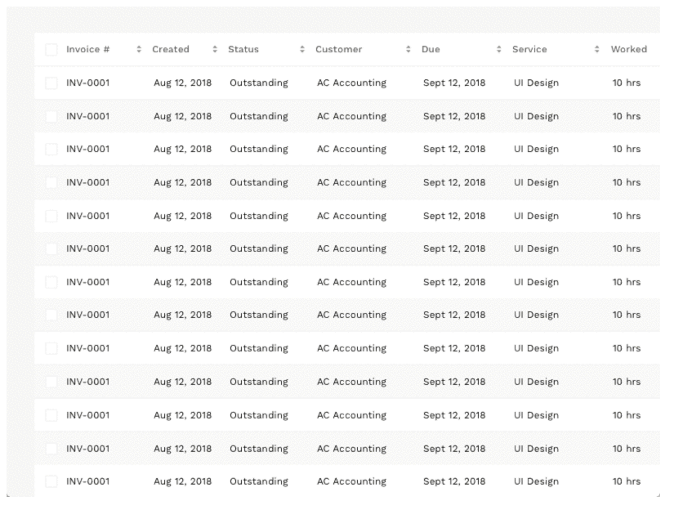

The row style helps users scan data. Reducing visual noise by removing row lines or zebra stripes works well for small datasets. Users may lose their place when parsing larger datasets. Line divisions help users keep their place. Alternating rows (aka zebra stripes) help users keep their place when scanning long horizontal datasets. Although they cause usability problems when there is a small number of rows because users may ascribe meaning to the highlighted rows.

### Display Density

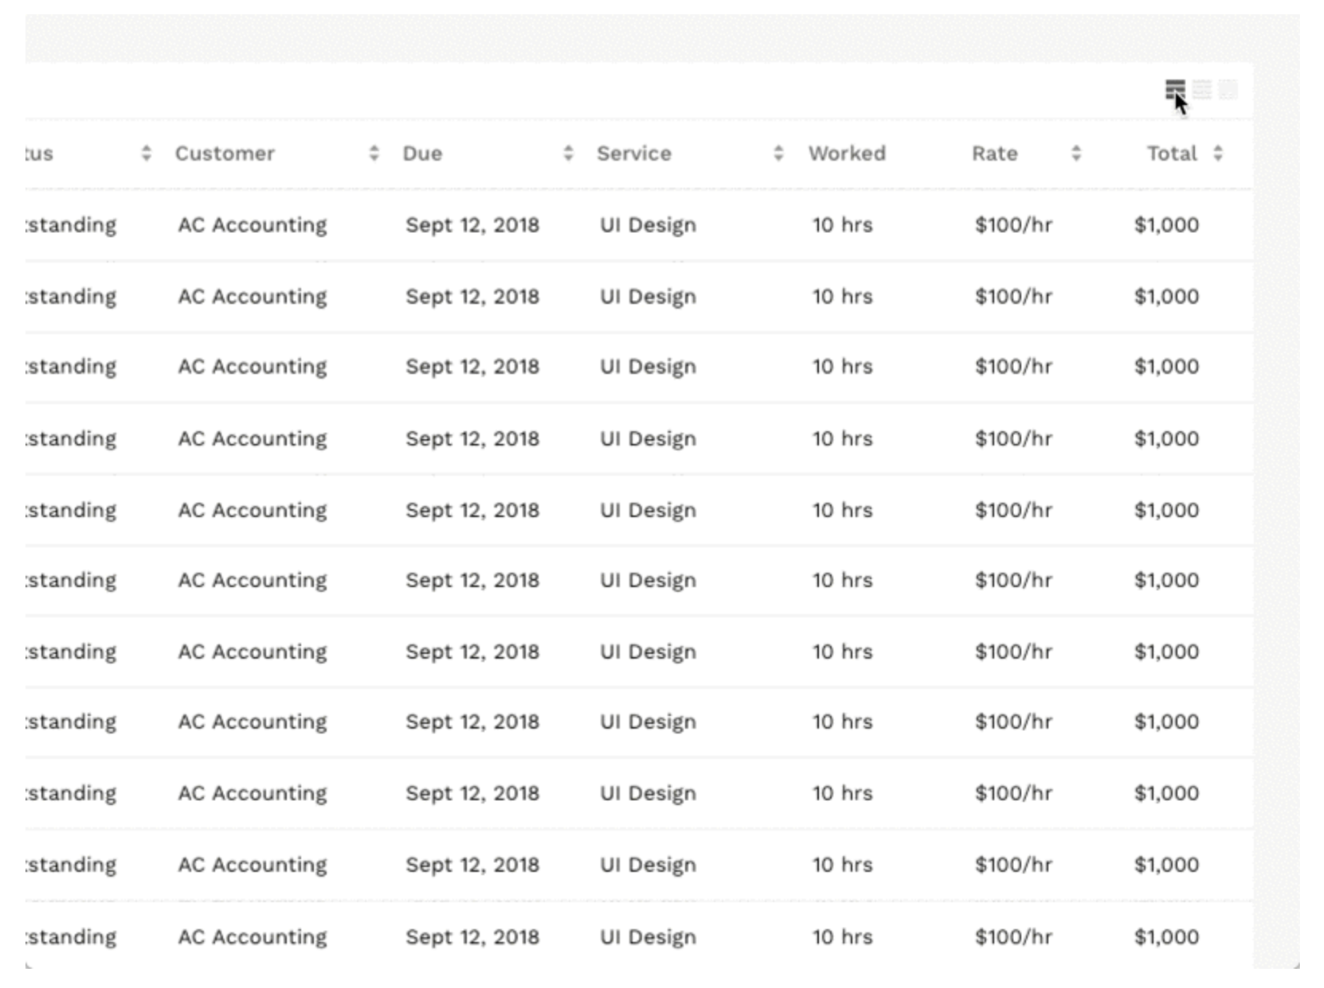

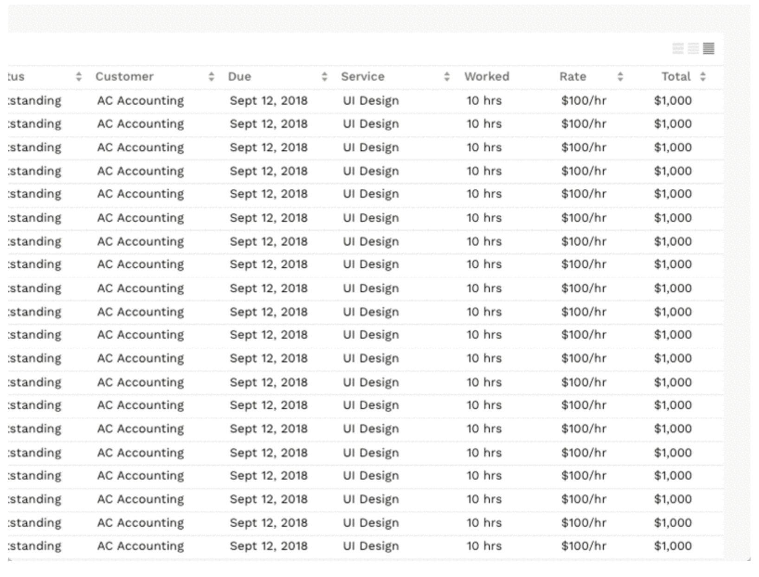

Smaller row height enables the user to view more data without the need for scrolling. However, it effects scannability leading to parsing errors. That is why many successful data table designs incorporate the ability to control display density.

### Pagination

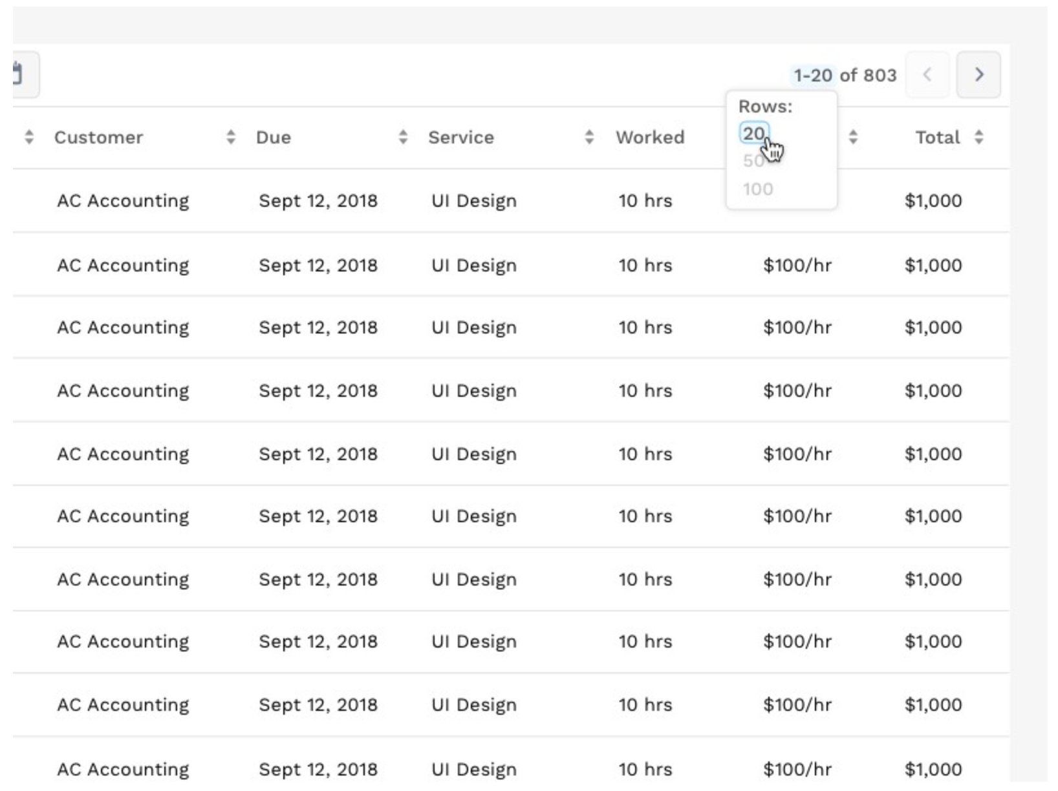

Pagination works by presenting a set number of rows in a view, with the ability to navigate to another set. The above example provides the ability to customize the row count per view. Infinite scroll often replaces this pattern. Infinite scroll progressively loads results as a user scrolls. Infinite scroll works well for discovery websites but is usually disastrous for prioritization apps.

### Expandable Rows

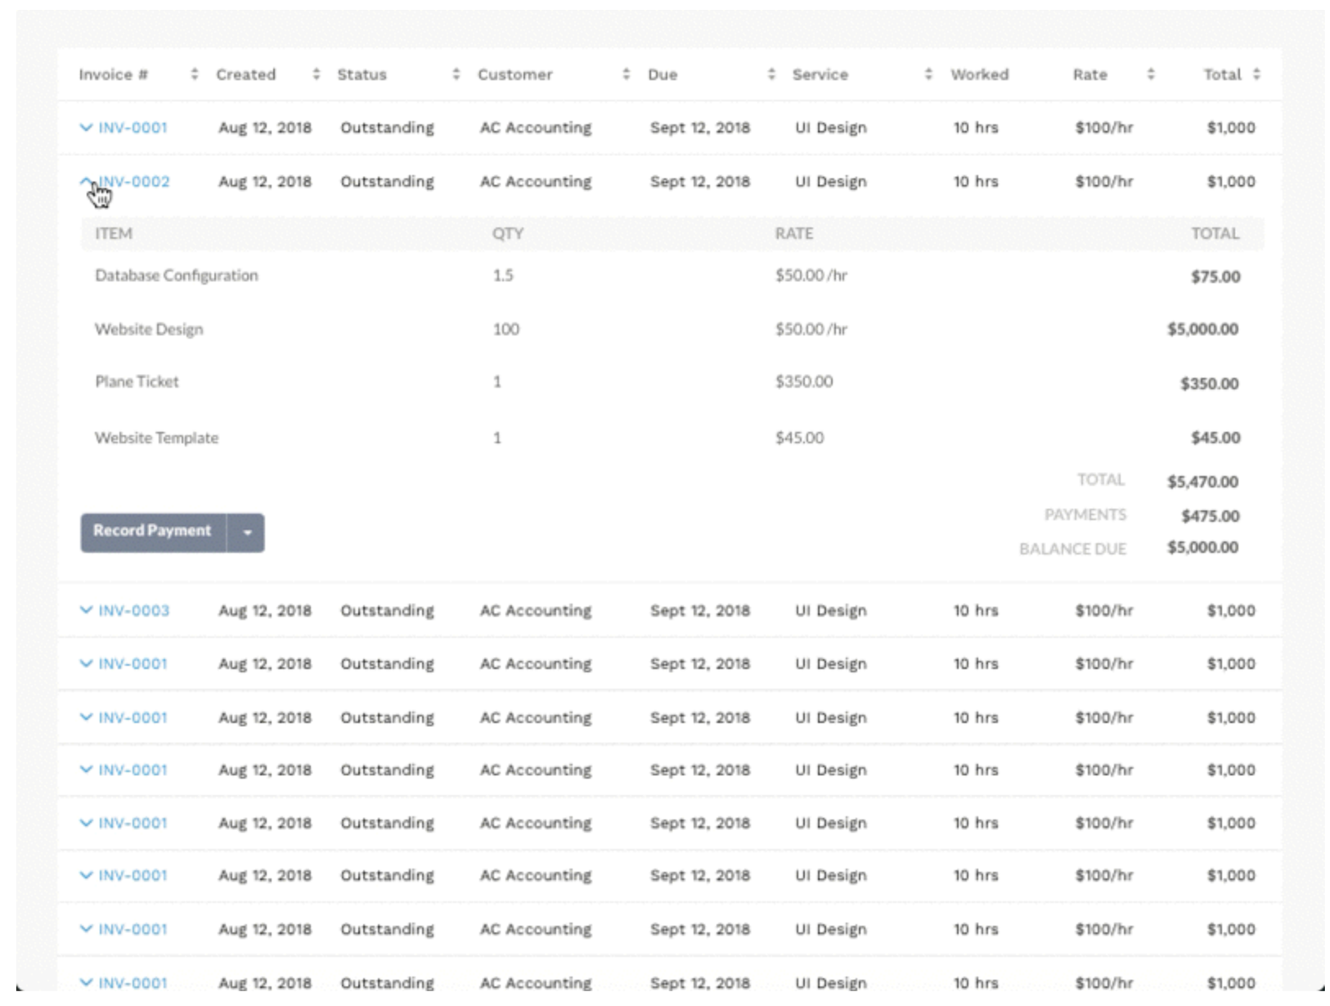

Expandable rows allow the user to evaluate additional information without losing their context

### Quick View

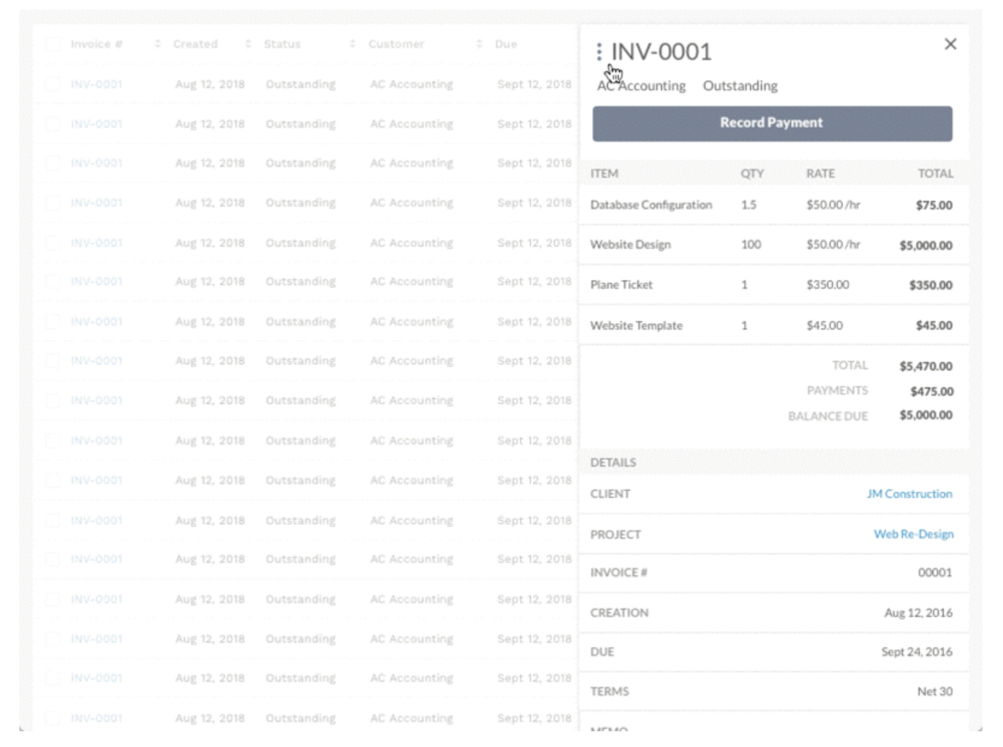

Much like expandable rows, quick view enables a user to view additional information while staying in-context.

### Modal

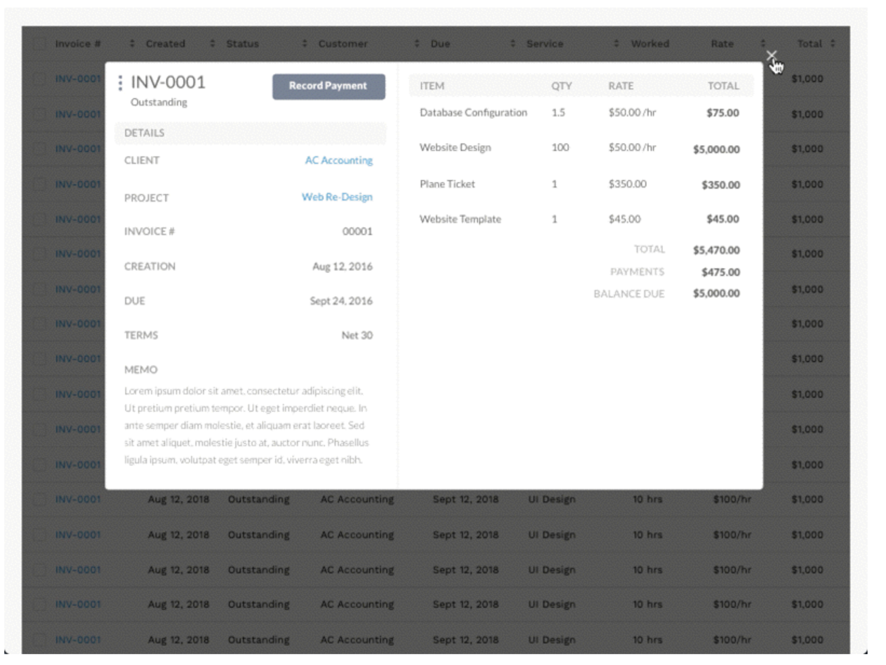

Modals allow the user to stay within the table view but provides more focus to the additional information and actions.

### Basic Filtering

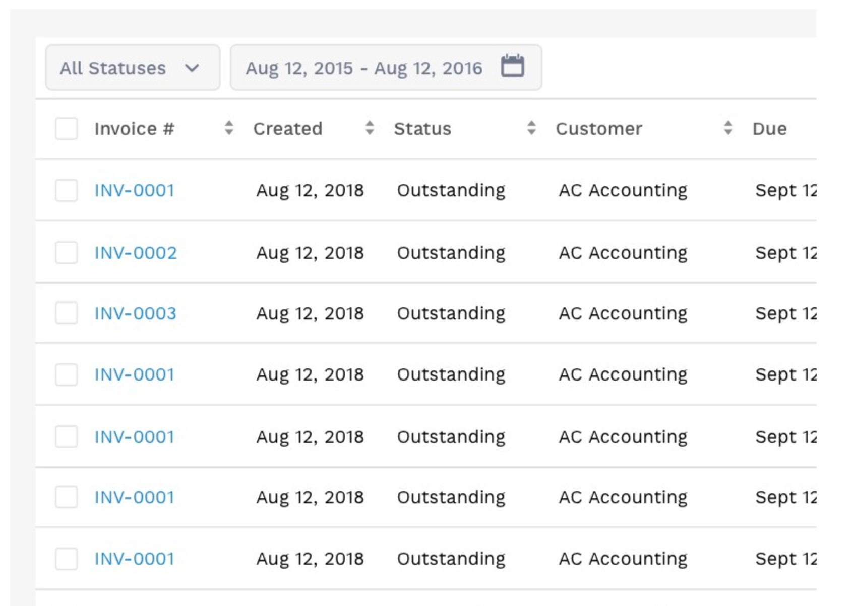

Basic filtering allows users to manipulate the data presented in the table.

### Searchable Columns

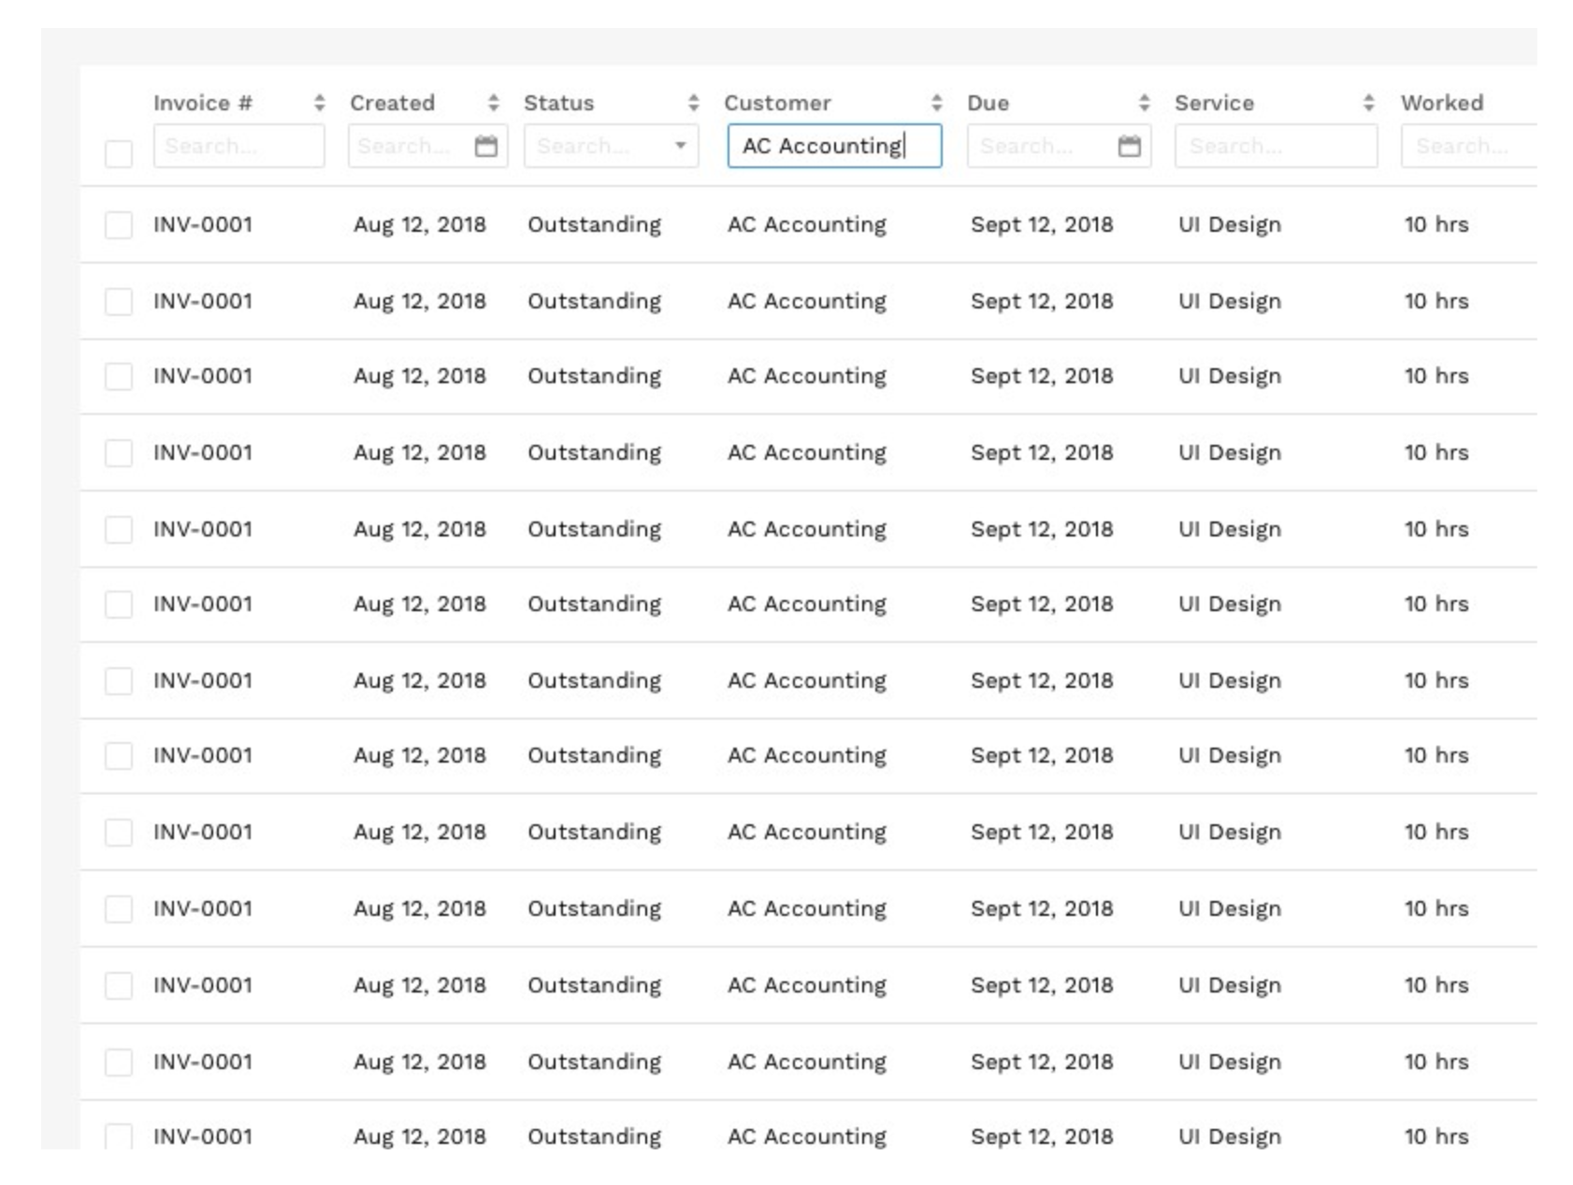

This design pattern allows a user to search specific values within each column.

Reference :

https://uxdesign.cc/design-better-data-tables-4ecc99d23356